Block Websites from Google Search Results using Personal Blocklist
When you search ‘Google’ for a specific keyword; for example- a product, you might have come across some sites which to get visits/ hits that are not useful to you or are under normal conditions unrelated to the keyword or item you were searching for. These sites may be objectionable/ dangerous websites, it is been known to happen on the Internet and if you aren’t careful you will be tricked by these links.
It might have happened to you too, let us know that in the comments.
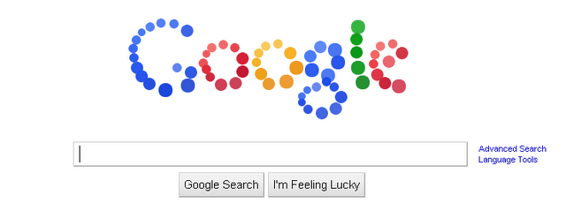
Chrome grasps the crown of most used web browser in the world. And to use it more efficiently & safely, Google created a Personal Blocklist by Google. Google created this extension to help its Chrome users to block content-farming sites.
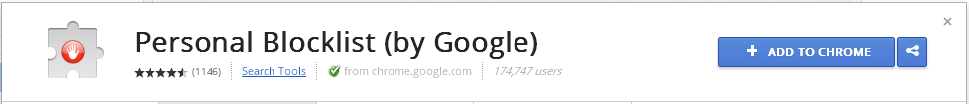
You can use it in very few steps, simply download the extension from chrome web store into your chrome browser.
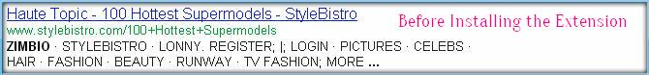
Search Google for something and you will find a blue link, (Block sitename.com) below the link to the website in search results.
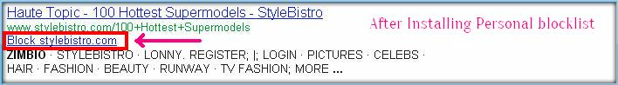
When you click on the Block website link the website will be blocked from showing up in search results again on Google. You can also use the extension icon in the browser toolbar to block the website you are currently viewing. The personal blocklist extension will send Google the patterns that you choose to block, the extension will also send Google the link of web pages where the blocked websites are displayed. You can also filter websites that are dominating your search results. And don’t forget to unblock them soon after you are done.
You can easily verify and edit the blocked websites by clicking the Personal Blocklist Extension Icon in the browser toolbar.
How did you like the extension? Shoot your comments below.

